Mishen Naidoo

ST10250201

CLDV6211 – POE Part 1

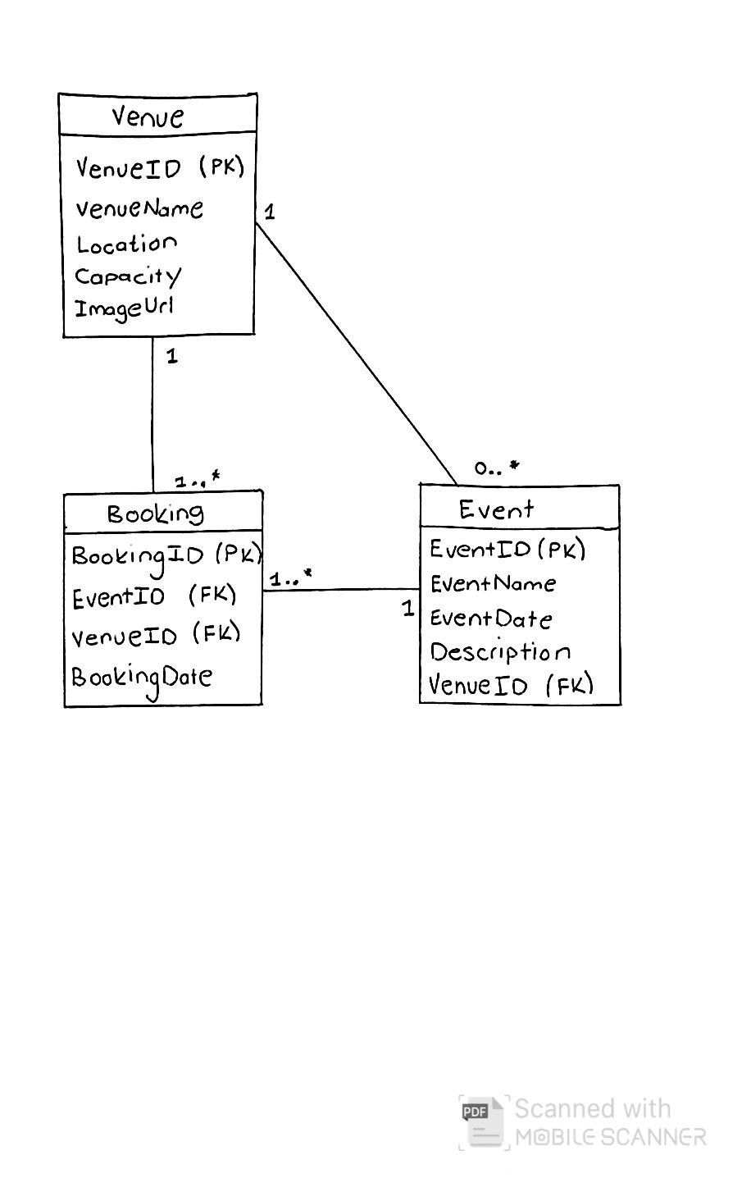A)

Entity Relationship Diagram

Database Script:

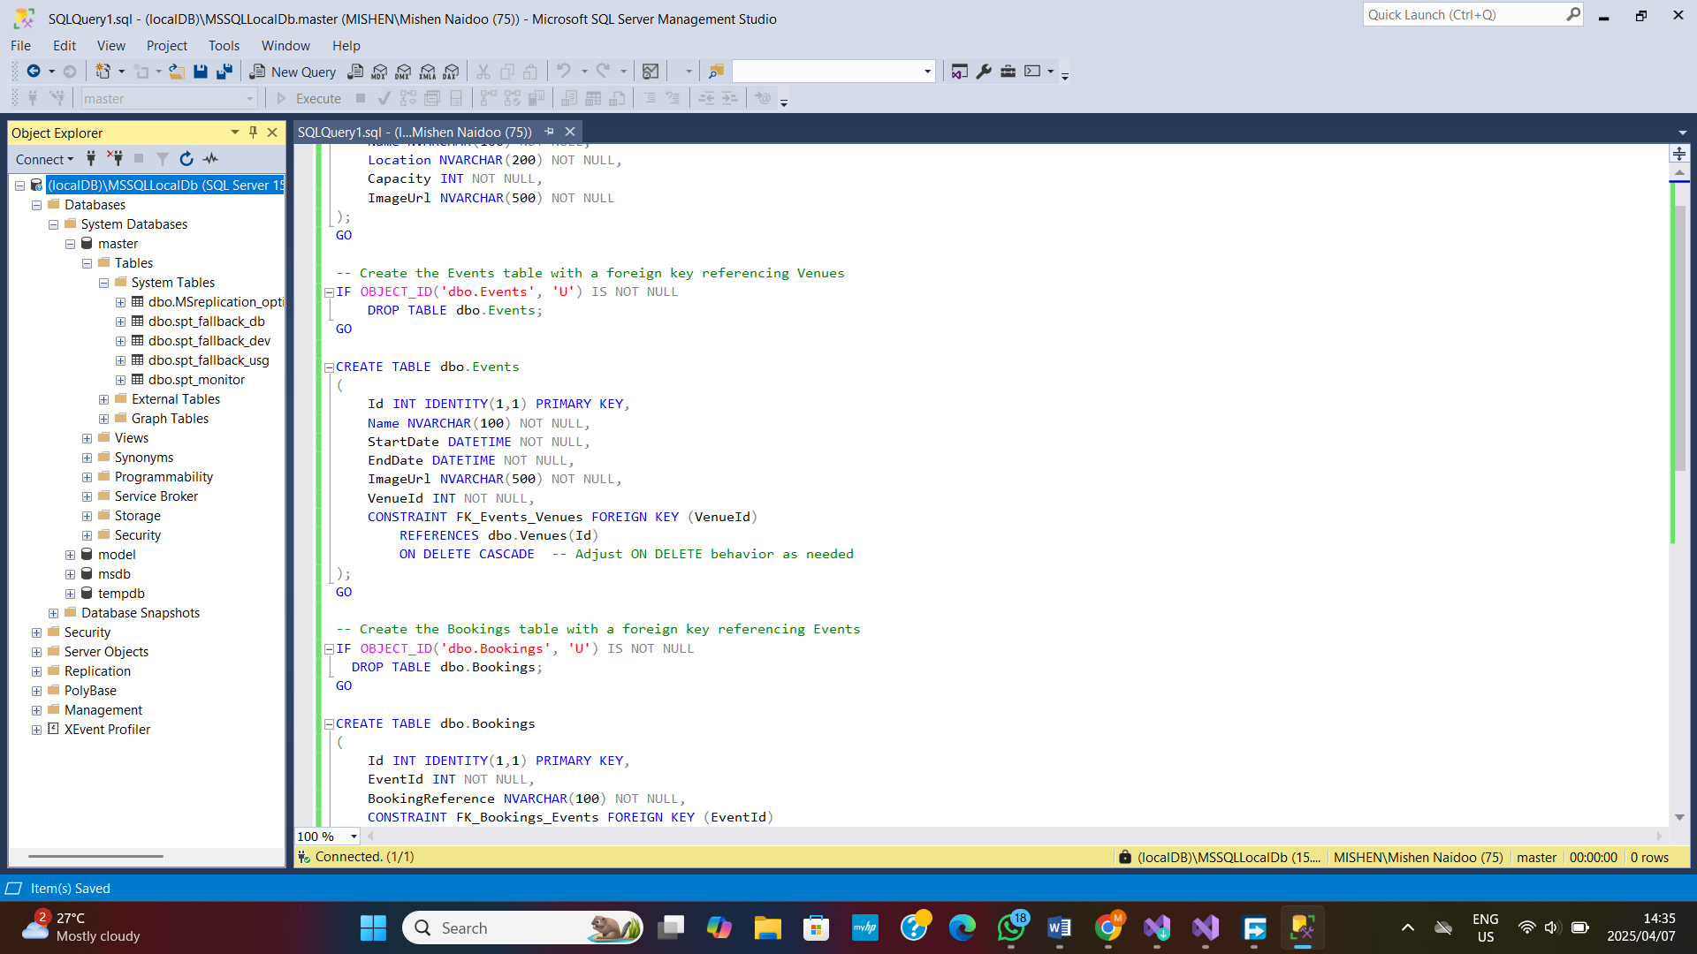

D)

Differences Between Cloud and On-Premises Deployments

1. Security -

Cloud Deployments:

Cloud companies like Microsoft Azure, Amazon Web Services, and Google Cloud Platform make significant investments in security. They include security features including network firewalls, intrusion detection systems, automated patch management, and compliance certifications (such as ISO and SOC 2). For example, Azure's Security Center analyzes workloads in real time and makes proactive security recommendations.

On-Premises Deployments:

On-premises implementations require the business to be responsible for every tier of security, from data center physical security to network and application security. This necessitates a large investment in hardware, employee training, and continual maintenance. While enterprises may adjust security to their own needs, they may not have access to the same advanced, automated security protections as the cloud.

2. Deployment Speed -

Cloud Deployments:

Cloud services make it possible to deploy resources quickly. Developers may create virtual machines, databases, and various services upon request using templates or automation tools such as Azure Resource Manager or AWS CloudFormation. This results in much shorter deployment cycles, often in minutes.

On-Premises Deployments:

On-premises deployments need manual configuration of physical gear, network configuration, and potentially long procurement procedures. This increases deployment time and decreases flexibility. In an actual data center, for example, configuring a new server group may take days or weeks.

3. Resource Management -

Cloud Deployments:

The cloud provides dynamic resource allocation and a pay-as-you-go basis. Services can be dynamically scaled based on request (automatic scaling), making it easier to handle peak loads without overprovisioning. This flexibility enables businesses to optimise both costs and performance.

On-Premises Deployments:

On-premises resource management often entails estimating demand and acquiring hardware ahead of time, which can result in over-provisioning or under-provisioning. Scalability is constrained by the actual hardware available, and expanding capacity may necessitate substantial cash investment and effort.

In comparison to on-premises configurations, cloud deployments provide improved security, faster setup, and dynamic resource management. Cloud services provide comprehensive, controlled security protections as well as the flexibility to grow fast, both of which are difficult to achieve on-premises.

The Key Differences Between IaaS, PaaS, and SaaS, and Why PaaS will benefit EventEase

Infrastructure as a Service (IaaS):

IaaS delivers virtualized computer resources via the Internet. The cloud provider provides the hardware (servers, storage, and networks), while the client handles the operating systems, software and applications.

An example is Microsoft Azure Virtual Machines. In relation to EventEase, IaaS provides control, but it necessitates monitoring the operating system, patching, scalability, and security configurations, all of which can divert attention away from key application development duties.

Platform as a Service (PaaS):

PaaS provides a fully cloud-based development and deployment environment. The provider controls the foundational framework, operating system, and execution, allowing developers to concentrate on application development and deployment.

An example is Azure App Service. In relation to EventEase, PaaS is great since it speeds up deployment by enabling developers to concentrate on the application's business logic rather than infrastructure administration. It simplifies scalability by dynamically responding to traffic needs and lowering the danger of double reservations caused by performance bottlenecks. PaaS also improves security and upkeep by allowing the service provider to manage updates and regular duties, guaranteeing the system stays updated with little work. It also readily connects with other cloud services like databases, caching, and messaging, allowing further scalability and feature extension.

Software as a Service (SaaS):

SaaS offers fully complete, already configured apps via the Internet. Users can use these apps without regard for the foundational structure or platform.

Examples are apps like Microsoft Office 365. In relation to EventEase, SaaS is less ideal for developing a tailored application such as the Venue Booking app since EventEase requires specialized functionality and control over business operations.

In conclusion, IaaS provides comprehensive oversight but needs substantial maintenance, and SaaS provides ready-to-use apps, PaaS achieves the right combination by offering an organized platform that allows developers to concentrate on the application. Using PaaS offers faster delivery time, more scalability, and fewer operational cost for EventEase, resulting in the best option for developing their new Venue Booking Service.

References

Hughes, A. (2018b). *Blog: On Premise vs. Cloud: Key Differences, Benefits and Risks | Cleo*. [online] Cleo. Available at: <https://www.cleo.com/blog/knowledge-base-on-premise-vs-cloud> [Accessed 6 Apr. 2025].

Flower, Z. (2021b). *On premises vs. cloud: The major similarities and differences*. [online] SearchCloudComputing. Available at: <https://www.techtarget.com/searchcloudcomputing/tip/Evaluate-on-premises-vs-cloud-computing-pros-and-cons> [Accessed 6 Apr. 2025].

Dinh, C. (2024b). *A Comprehensive Guide To On-Premise Deployment For Businesses | Relia Software*. [online] Reliasoftware.com. Available at: <https://reliasoftware.com/blog/on-premise-deployment> [Accessed 6 Apr. 2025].

Brightpattern.com. (2024b). *What is on-premises deployment of software?* [online] Available at: <https://www.brightpattern.com/what-is-on-premises-deployment-of-software/> [Accessed 6 Apr. 2025].  
2025 (2025). *What Is Cloud Deployment? | Cognizant*. [online] www.cognizant.com. Available at: <https://www.cognizant.com/us/en/glossary/cloud-deployment>.

Scale Computing. (2024). *What is Application Deployment?* [online] Available at: <https://www.scalecomputing.com/resources/application-deployment-tools-techniques-and-best-practices> [Accessed 6 Apr. 2025].

Raza, M. (2024). *SaaS vs PaaS vs IaaS: What’s The Difference and How To Choose*. [online] BMC Blogs. Available at: <https://www.bmc.com/blogs/saas-vs-paas-vs-iaas-whats-the-difference-and-how-to-choose/> [Accessed 6 Apr. 2025].

Google Cloud. (2025). *PaaS vs IaaS vs SaaS: What’s the difference?* [online] Available at: <https://cloud.google.com/learn/paas-vs-iaas-vs-saas?hl=en>. [Accessed 6 Apr. 2025].

IBM (2021). *IaaS, PaaS and SaaS*. [online] Ibm.com. Available at: <https://www.ibm.com/think/topics/iaas-paas-saas> [Accessed 6 Apr. 2025].

BigCommerce (2022). *SaaS vs. PaaS vs. IaaS: Examples & How to Tell Them Apart*. [online] BigCommerce. Available at: <https://www.bigcommerce.com/articles/ecommerce/saas-vs-paas-vs-iaas/> [Accessed 6 Apr. 2025].

Published (2023). *IaaS, NaaS, PaaS, and SaaS: How Are They Different?* [online] Megaport. Available at: <https://www.megaport.com/blog/iaas-naas-paas-and-saas-how-are-they-different/> [Accessed 6 Apr. 2025].

Rosencrance, L. (2021). *SaaS vs. IaaS vs. PaaS: Differences, Pros, Cons and Examples*. [online] WhatIs. Available at: <https://www.techtarget.com/whatis/feature/SaaS-vs-IaaS-vs-PaaS-Differences-Pros-Cons-and-Examples> [Accessed 6 Apr. 2025].